**2025 Member Lite Launch**

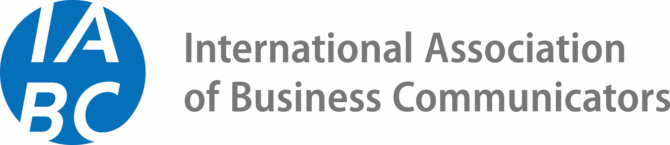

*Sample Messaging Supplement To Campaign Brief*

## Overview

As we approach our planned 10 September launch date of IABC Lite Membership, we want to equip IABC Leaders with sample email, social media and website copy for consistent messaging across platforms.

Please feel free to use the following samples as starting points for your upcoming communications!

Questions? Reach out to us at [leader_centre@iabc.com](mailto:leader_centre@iabc.com).

### Key Messaging

* **"Why IABC?"**

Communication is your career — and your community is here. IABC connects you to people, knowledge, and opportunities that elevate your work and support your growth.

* **"What do you get with IABC Lite Membership?"**

You get access to the essentials of IABC: a global network, professional development content, and exclusive discounts on live events. It’s everything you need to get started with IABC, minus the full cost.

* **"What makes IABC different?"**

We’re the premier global association focused on the communication profession, with members worldwide and a 55-year track record of advancing communication as a strategic business function.

## Graphics and Sizing

We will deliver sample graphics sized for use on **websites**, in **email**, and across **social media platforms** for all IABC Leaders to use.

## Sample Emails

#### For Prospect Audiences

*Subject Line*: New to IABC? Start Smart with IABC Lite Membership — Just $115

*Header*: Your Global Communications Community, Now Easier To Join.

*Body Copy*:

Curious about IABC but not quite ready to commit? With the new IABC Lite Membership, you can access essential IABC benefits at a lower price point of just $115 USD/year.

You’ll gain access to:

* Access to global networking through our Online Community
* Entry into Shared Interest Groups (SIG) and IABC’s online Community
* Curated thought leadership content and webinars
* A 5% discount on live events hosted by IABC International

Whether you're testing the waters or coming back after a break, Lite membership is your entry point to an international network of communicators ready to connect, grow, and lead.

Learn more and get started today!

*CTA Button*: [Explore IABC Lite Membership]

#### For Current Chapter/Region Members

*Subject Line:* More Access, More Community — Meet IABC Member Lite

*Header*: Grow Our Local IABC Community, Starting at $115

*Body Copy*:

Exciting news! IABC has introduced a new IABC Lite Membership tier, designed to make IABC more accessible to communication professionals at all stages of their careers.

Those who join IABC at this new, core membership tier can take advantage of:

* Entry to IABC Shared Interest Groups (SIGs) and IABC’s Online Community for year-round, virtual networking
* Curated content relevant to the communication profession
* A discount on international events
  + *[please feel free to modify, depending on your local Member Lite access tier]*

This is a great way to re-engage former members, welcome new professionals, or offer a lower barrier for those interested in getting involved.

Let’s grow our community together!

*CTA Button*: [Help Spread The Word]

## Sample Social Posts

* Communication is your career — and your community is here. IABC connects you to people, knowledge, and opportunities that elevate your work and support your growth. Learn more about our new IABC Lite Membership offering today!
* 🌎 Why join IABC? Because you don’t need to navigate your career alone. With the new **IABC Lite Membership**, you can connect with communicators worldwide, access thought leadership, and build your skills for just **$115/year**. Join the only global community dedicated to elevating communication as a force for business success. <https://www.iabc.com/membership/join>   
  #IABCMemberLite #CommsCareer #IABCMembership
* A global network. Real community. Proven impact.  
  Join IABC with Lite Membership — just $115/year for events, insights, and global connections.   
  Why wait? 👉 <https://www.iabc.com/membership/join> #IABCMemberLite #CommsProfessionals #Communication #IABCMembership
* Meet IABC Lite Membership, your budget-friendly way to grow as a communicator. Access a global network and professional content, all for less than your monthly coffee habit. Learn more today: <https://www.iabc.com/membership/join> #IABCMemberLite #CommsProfessionals #IABCMembership